U.S. judge approves $1.8M settlement of overtime pay dispute against Sheetz Inc.
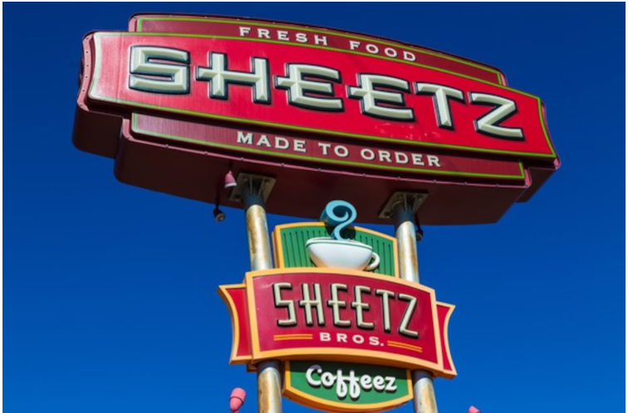
A federal judge Wednesday gave final approval to a $1.8 million settlement of an overtime pay lawsuit employees filed against convenience store giant Sheetz Inc.

- Matt Miller | mmiller@pennlive.com
- Updated: Jun. 26, 2019, 5:20 p.m.
- |Published: Jun. 26, 2019, 3:45 p.m.

U.S. Middle District Judge John E. Jones III’s decision means more than 700 Sheetz assistant managers in Pennsylvania alone will receive payments averaging $1,619, according to court filings.
The settlement stems from a fair wage lawsuit two Sheetz workers, William Cambridge of Tyrone and Mary Penatzer of State College, lodged in September 2017.

